

**PH450 Project Report 2018-19**

Experimental Technologies for Magneto-Optical Trapping

**Submitted in partial fulfilment for the degree of Masters of Physics**

Stuart Smyth

Registration No.: 201527054

*SUPA Department of Physics, University of Strathclyde, Glasgow G4 0NG*

Dr Oliver Burrow

*Primary Supervisor*

Dr Paul Griffin

*Secondary Supervisor*

(Dated: 10th March 2019)

# Abstract

In a few sentences, concisely summarise your project and results. Indicate what research problem was addressed, the methods used, and the main conclusions.

# Preface

State explicitly how your dissertation relies on the work of others, highlighting the portions that you claim to be your own original work. E.g. “The results presented in chapter 3 rely upon a simulation data provided by the research group. The data analysis is entirely my own work. The analysis in chapter 4 was performed in conjunction with my supervisor…” etc. Without clarifying statements, it will be assumed that your thesis is a review article with no original content. Be sure to claim only your own work, any evidence to the contrary may leave you susceptible to charges of plagiarism.

# Acknowledgements

You may want to acknowledge people who have helped you in your project.

# Contents

Abstract i

Preface ii

Acknowledgements iii

Contents iv

List of Figures vi

List of Tables vii

I. Introduction 1

1.1 Aims and Motivation 1

1.This is a sub-subsection 1

1.2 Laser Cooling and Magneto Optical Traps 1

1.3 Diffraction Grating Magneto Optical Traps 1

II. Theory 2

III. Methods 3

3.1 Experimental setup 3

3.2 Control of Errors 3

3.3 Experimental setup 3

IV. Results 4

4.1 Three Face Grating Measurements 4

4.1.1 0th Order Efficiency 4

4.1.2 1st Order Efficiency 5

4.1.3 Radiation Balance 6

4.1.4 Polarisation Efficiency 7

4.2 Four Face Grating Measurements 8

4.2.1 Variations in X-axis 8

4.2.2 Variations in Y-axis 10

4.2.3 1st Order Efficiency Asymmetry 12

5 Conclusions 13

6 Appendix A: First Appendix 14

7 Appendix B: Second Appendix 15

8 References 16

# List of Figures

Figure 1 Experimental Setup for Measuring Power Values 3

Figure 2: 0th order efficiency for each grating face for three gratings 5

# List of Tables

Table 1: gmot. 2

Table 1: Table showing 0th order efficiency values with errors 4

# Introduction

## Aims and Motivation

Some text and a reference [1].

## Laser Cooling and Magneto Optical Traps

### Doppler Laser Cooling

### 

## Diffraction Grating Magneto Optical Traps

### Some text

* + 1. Diffraction Grating Manufacturing

# Theory

## Key Parameters of Diffraction Gratings for GMOTs

## Determining Diffraction Grating Efficiency

Table 1: example table.

|  |  |
| --- | --- |
| 1 | 2 |
| 3 | 4 |

# Methods

## 3.1 Experimental setup

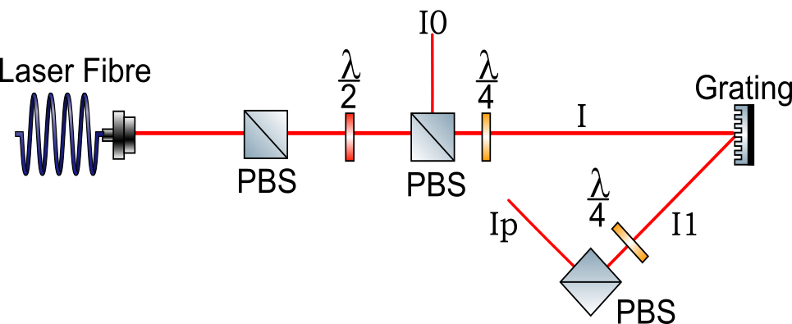

Figure Experimental Setup for Measuring Power Values

## 3.2 Control of Errors

## 3.3 Data Collection

# Results

## Three Face Grating Measurements

### 0th Order Efficiency

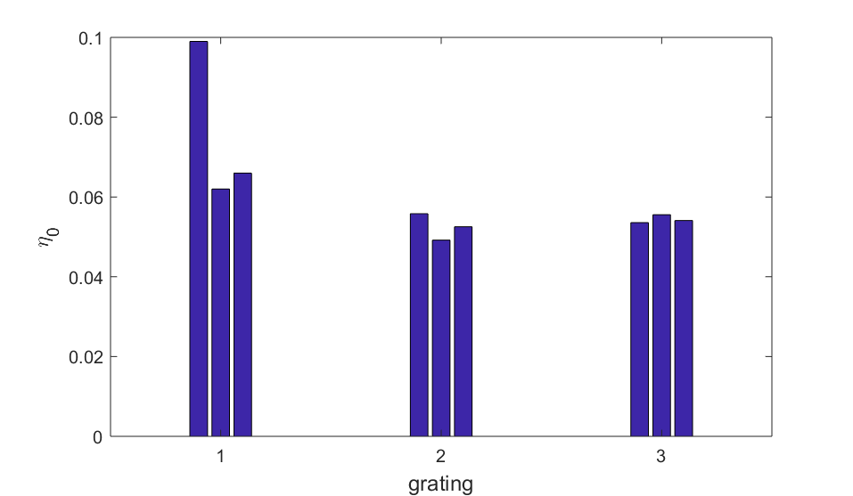

Figure : 0th order efficiency for each grating face for three gratings

Some sentences explaining what plot shows. old gratings to new, eta 0 become far more uniform and reduces < 6%0th order efficiency for each grating face for three gratings

### 1st Order Efficiency

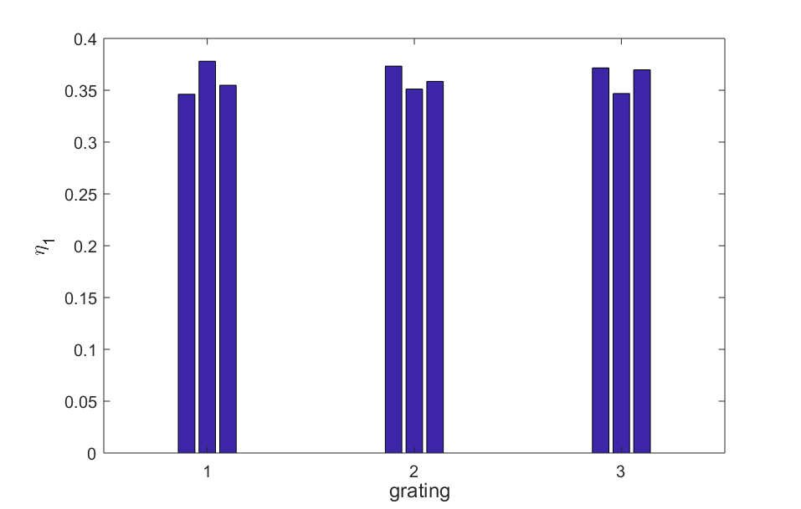

Figure : 1st order efficiency for each grating face for three gratings

Some sentences explaining what plot shows. old gratings to new, eta 1 for each face would ideally be the same and be = 1/3

### Radiation Balance

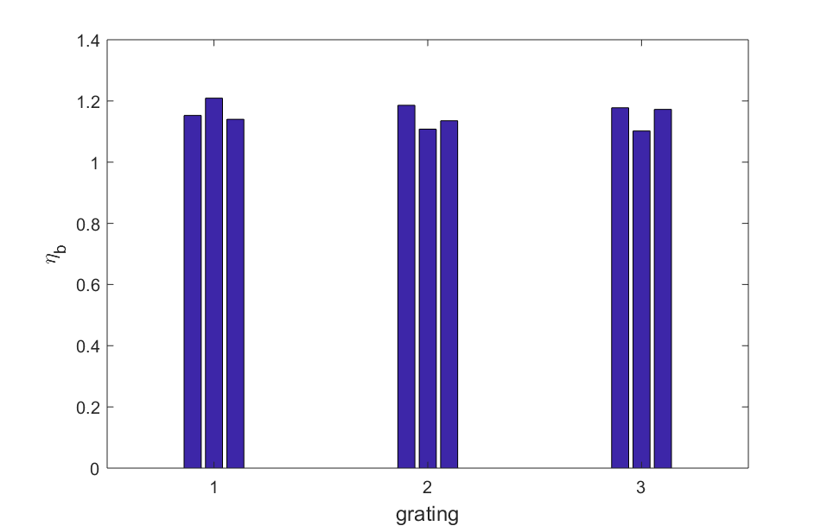

Figure : Radiation Balance parameter for each grating face for three gratings

Some sentences explaining what plot shows. old gratings to new, radiation balance ideally one , absolute minimum 0.9, real world about 1.15, mystery power loss

### Polarisation Efficiency

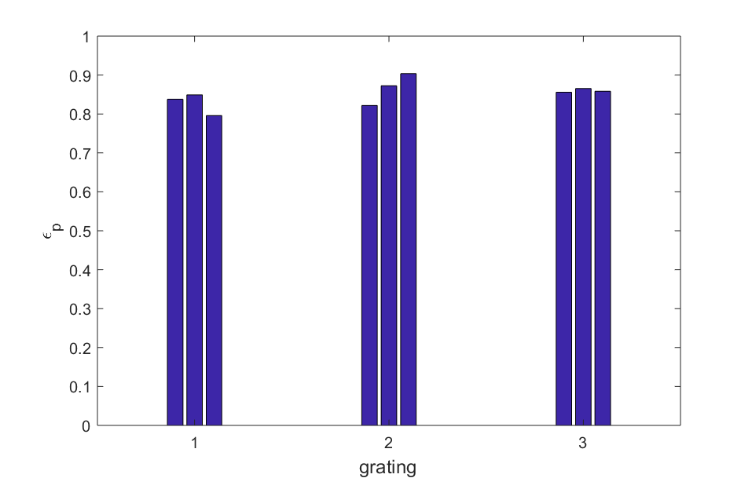

Figure : Polarisation efficiency for each grating face for three gratings

Some sentences explaining what plot shows. Previous papers show >90%, slightly below due to not being able to measure transmitted power, high optical loss in PBS transmitted power.

## Four Face Grating Measurements

### Variations in X-axis

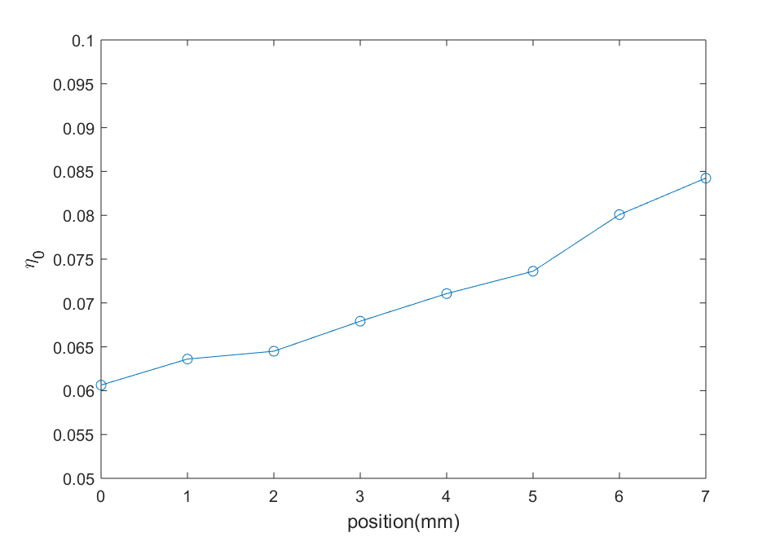

Figure : 0th order efficiency vs position on the x-axis of grating face

0th order increase as laser moves towards the edge of the grating, value is very high >6%

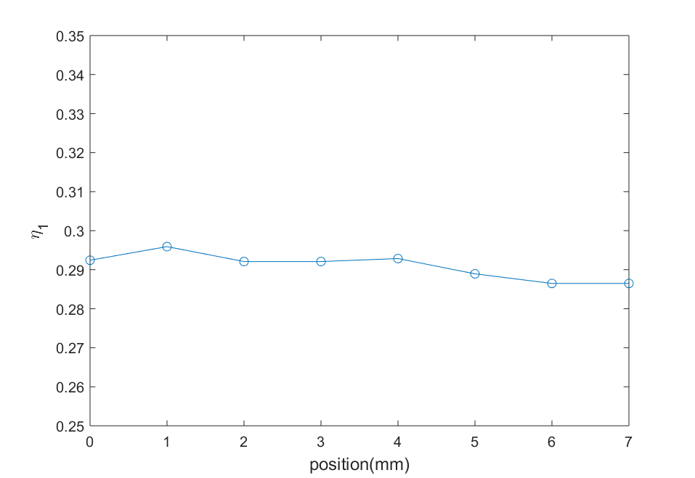

Figure : 1st order efficiency vs position on the x-axis of grating face

1st order decreases as laser moves to edge of the grating, moving away from optimum value 0f 0.33.

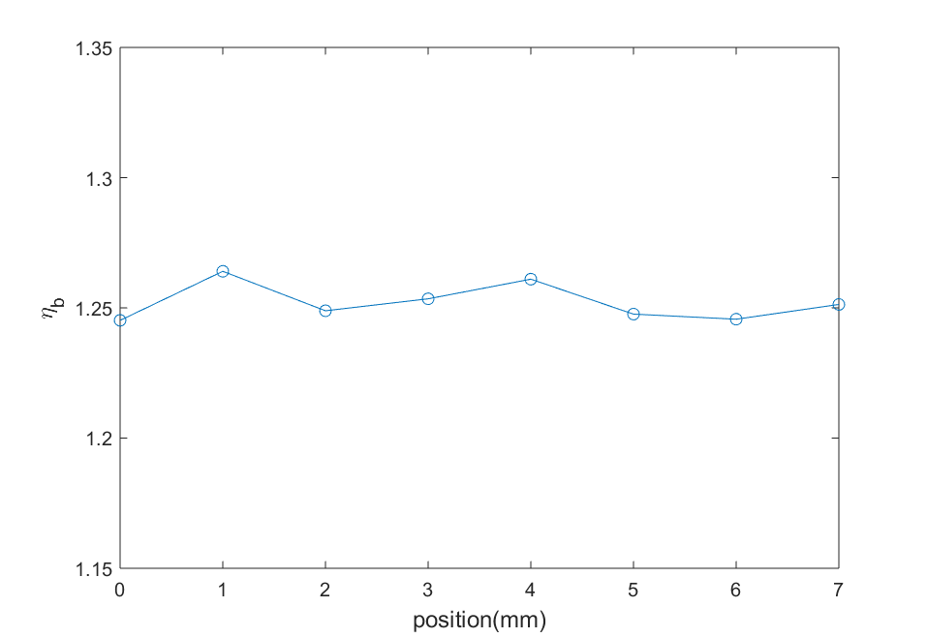

Figure : Radiation Balance Parameter vs position on the x-axis of grating face

Radiation balance stays roughly the same as eta0 increase eta1 increase. Value is well over optimum value of 1 . both parameters too high / too low.

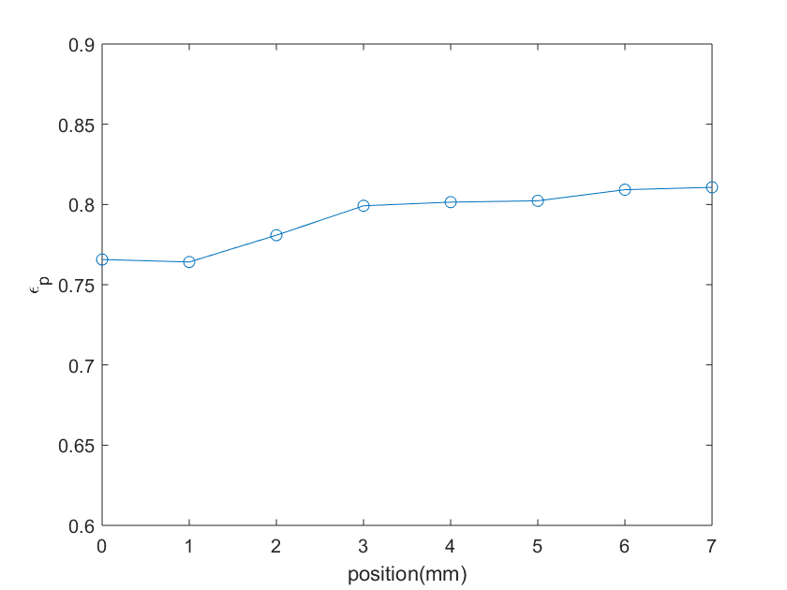

Figure : Polarisation efficiency vs position on the x-axis of grating face

Overall polarisation eff low. Very low near x = 0 increases then becomes steady as x>

### Variations in Y-axis

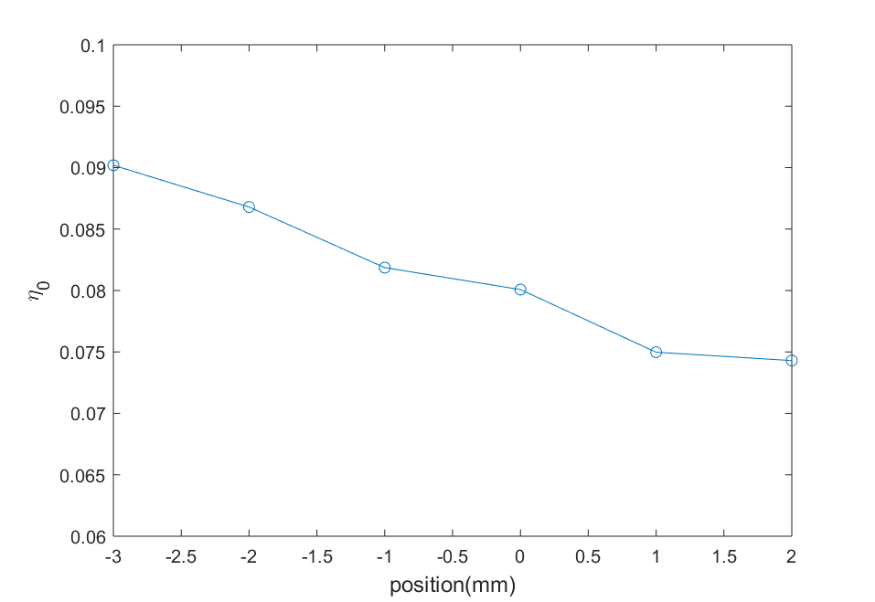

Figure : 0th order efficiency vs position on the y-axis of grating face

0th order decreases as laser moves down the grating, value is very high almost 10%

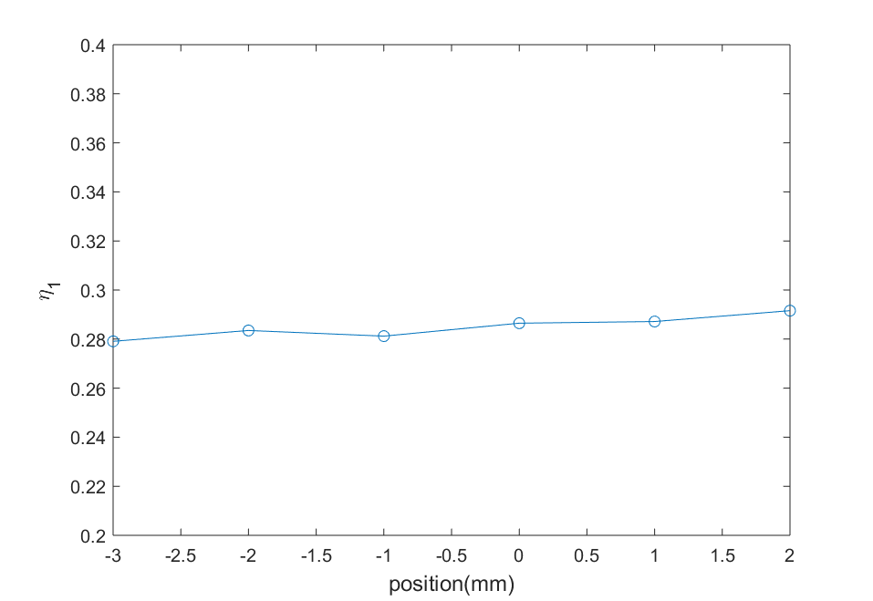

Figure : 1st order efficiency vs position on the y-axis of grating face

1st order increase slightly as laser moves down the grating, still below 33%

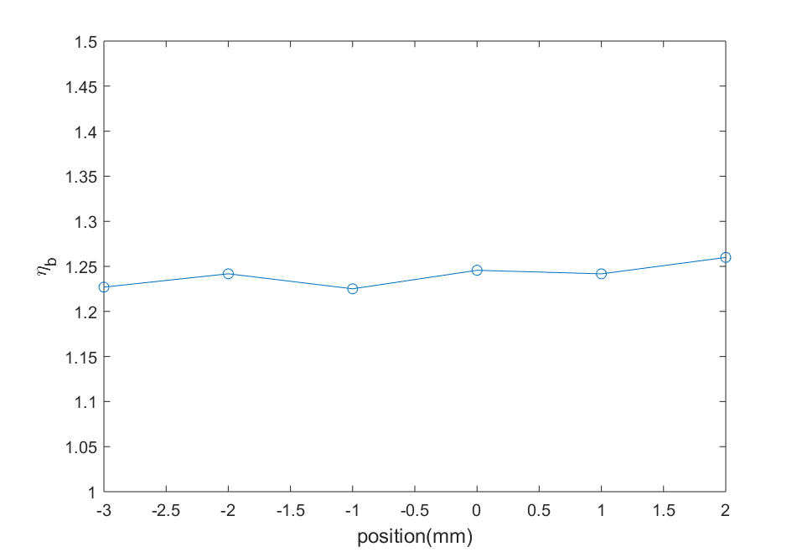

Figure : Radiation Balance Parameter vs position on the y-axis of grating face

Radiation balance stays roughly the same as eta0 increase eta1 increase. Value is well over optimum value of 1. both parameters too high / too low.

Generally, can see the grating face is not uniform in x and y axis. Investigation by my supervisor found that during manufacture the resist was not evenly applied.

### 1st Order Efficiency Asymmetry

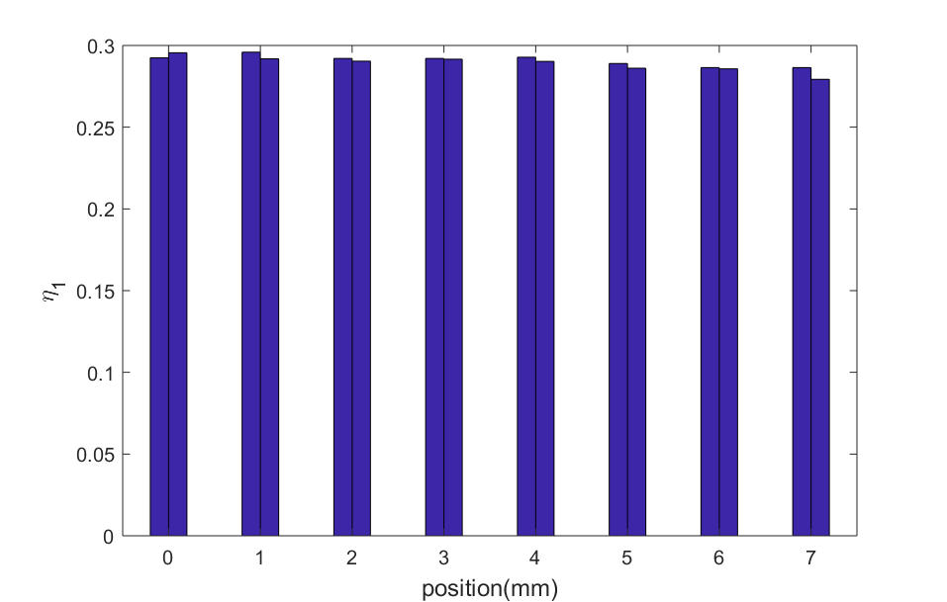

Figure : 1st order efficiency in negative and positive direction as function of x position on grating face

Shows no overall asymmetry, variations are within margin of error (refer to error values), was concern of other group members. Early gratings had asymmetry? but now not present.

# Conclusions

# Appendix A: First Appendix

# Appendix B: Second Appendix

# References

|  |  |
| --- | --- |
| [1] | J. Smith, “Some title,” *J. Interesting Results,* vol. 34, pp. 34-37, 1999. |